

Assessment Cover Page
Student Full Name
Kyle O’Reilly

Student Number
Sba26104

Module Title
Strategic Thinking

Assessment Title
CA-1 Capstone Project Proposal

Lecturer/Supervisor
Taufique Ahmed

Assessment Date
25/10/2026

Date of Submission
25/10/2026

Github Repository
https://github.com/sba26104-KOR/HDSDAB---Strategic-Thinking---Capstone-Project.git

Use of AI Tools
I acknowledge the use of Chat GPT (OpenAI) for the purpose of brainstorming, code debugging, paraphrasing, grammar proofreading and Harvard referencing guidance.
Declaration
By submitting this assessment, I confirm that I have read the CCT policy on academic misconduct and understand the implications of submitting work that is not my own or does not appropriately reference material taken from a third party or other source.
I declare it to be my own work and that all material from third parties has been appropriately referenced.
I further confirm that this work has not previously been submitted for assessment by myself or someone else in CCT College Dublin or any other higher education institute
ion.
Table of Contents
1. Project Title 1
2. Introduction 1
3. Problem Definition 2
4. Aim, Objectives and Hypothesis 2
5. Project Scope 3
6. Methodology 4
7. Data Sources 5
8. Expected Deliverables 5
9. Project Timeline 6
10. Ethical and Legal Considerations 6
References 7

1. Project Title
Assessing the Accuracy of Machine Learning Models in Predicting Future Stock Closing Prices: A Comparative Case Study of Three Companies with Different Volatility Classifications.

2. Introduction
Predicting future stock prices is an important area of financial research, as accurate forecasts can help investors and financial institutions make more informed decisions and manage investment risk. However, stock markets are difficult to predict because prices are influenced by several factors, including economic conditions, company performance, political events, and investor sentiment (Jeribi et al., 2024; Zain-ul-Abideen et al., 2024).
Historical stock market data can be analysed using machine learning techniques to identify patterns and relationships that may help forecast future price movements. Khuwaja et al. (2020) highlight the challenges associated with financial data, including its unpredictable, noisy and non-linear characteristics. These challenges have encouraged researchers to investigate different predictive modelling techniques.
Recent research has explored the effectiveness of machine learning algorithms in forecasting stock market behaviour. Indra et al. (2025) compared Linear Regression, Random Forest and other machine learning models when predicting stock returns over different time periods. Their findings demonstrated the difficulties of achieving reliable predictions, even when using advanced algorithms. This highlights the importance of evaluating model performance rather than assuming that more complex techniques will automatically produce more accurate forecasts.
This Capstone Project proposes to investigate the accuracy of Linear Regression, Random Forest Regressor and a naïve time-series forecasting baseline when predicting stock prices 20 trading days into the future. Three publicly traded companies: JPMorgan Chase & Co., Coca-Cola Co. and Intel Corp. will be examined to compare forecasting performance across stocks selected to represent different volatility risk classifications displayed on Trading 212 (Trading 212, n.d).
This project will use historical stock closing prices and quantitative data analytics techniques to generate forecasts and compare them against actual closing prices. The aim is to determine which forecasting method produces the smallest prediction errors for each company and investigates whether differences in Trading 212’s volatility classifications are associated with differences in forecasting accuracy.

3. Problem Definition
Predicting future stock closing prices is challenging due to market volatility, uncertainty and the unpredictable nature of financial data. Historical stock prices often contain noise and non-linear patterns, making accurate forecasting difficult (Khuwaja et al., 2020).
Although machine learning models are used in stock market forecasting, their accuracy can vary depending on the model and market conditions. Indra et al. (2025) highlight the importance of comparing different machine learning approaches to evaluate their predictive performance.
This Capstone Project investigates whether Linear Regression and Random Forest Regressor can accurately predict stock closing prices 20 trading days ahead more accurately than a naïve time-series baseline. It will also examine whether forecasting errors differ between three stocks selected using Trading 212’s low, medium and high volatility classifications.

4. Aim, Objectives and Hypothesis
Aim:
To compare the accuracy of Linear Regression, Random Forest Regressor and a naïve time-series forecasting baseline when predicting stock closing prices 20 trading days after a common historical cut-off date for JPM.US, KO.US and INTC.US.
Objectives:
- Select JPM.US, KO.US and INTC.US, and use Trading 212 published volatility classifications to justify their selection as stocks representing low, medium and high volatility.
- Collect, clean and analyse historical stock data from Stooq and prepare simple historical price features for the forecasting models.
- Develop Linear Regression and Random Forest Regressor models and establish a naïve baseline for each selected stock.
- Generate nine predictions and compare them with three actual stock closing stock prices 20 days after the common historical cut-off date.
- Calculate individual prediction errors, compare forecasting approaches and discuss observed difference between the selected stocks.
Hypothesis:
The stock classified as having high volatility by Trading 212 will have the highest average absolute percentage forecasting error across the three forecasting methods. This exploratory hypothesis cannot be generalised from one target date per stock.

5. Project Scope
This Capstone Project will examine three individual stocks: JPMorgan Chase & Co., Coca-Cola Co., and Intel Corp. These stocks have been selected to represent low, medium, and high volatility classifications, respectively, as displayed on Trading 212 (Trading 212, n.d.). The classifications will be used to compare forecasting accuracy across the selected stocks, without independently calculating historical volatility.
Historical stock data covering approximately 44-46 years, where available, will be obtained from Stooq. The analysis will focus on historical closing prices and simple price-based indicators derived from previous trading days. Other factors, such as financial news, economic conditions and company announcements, will not be included in the forecasting models.
The study will use one common historical cut-off date to predict each stock’s closing price 20 trading days into the future. Three forecasting methods will be compared: Linear Regression, Random Forest Regressor and a naïve time-series forecasting baseline. This will produce nine predictions, which will be compared against three actual historical closing prices using absolute error and absolute percentage error.
The project will not involve live trading, automated investment decisions or financial recommendations. As only one future closing price will be evaluated for each stock, the findings will be limited to this case study and cannot establish which forecasting method is consistently more accurate across different market conditions.

6. Methodology
This Capstone Project will adopt a quantitative research approach, using historical numerical stock market data to evaluate forecasting accuracy. The methodology will compare Linear Regression, Random Forest Regressor and a naïve time-series baseline across three companies selected using Trading 212’s low, medium and high volatility classifications.
Data Collection and Preparation
Daily historical stock prices for JPMorgan Chase & Co., Coca-Cola Co., and Intel Corp. will be obtained from Stooq, using approximately 44-46 years of data where available. The datasets will be cleaned, checked for missing values and organised chronologically. Historical stock closing prices will be used to calculate lagged prices and moving averages as predictive features.
Predictive Modelling
Linear Regression will be used to identify linear relationships between historical prices and future closing prices. Random Forest Regressor will combine multiple decision trees to model potentially non-linear relationships (Indra et al., 2025; Divyashree et al., 2024).
A naïve time-series forecasting baseline will be also included, assuming that the closing price 20 trading days ahead will equal the last observed closing price. This provides a simple benchmark against which the machine learning models can be compared.
Testing and Evaluation
A common historical cut-off date will be selected, with only information available on or before that date used to generate the forecasts. The machine learning models will be trained using historical observations for which the 20-trading-day-ahead target price is already know by the cut-off date.
Each forecasting method will predict the closing price of 20 trading days ahead for each company, producing nine predictions in total. These predictions will then be compared against the actual historical closing prices.
Forecasting accuracy will be evaluated using absolute error and absolute percentage error. The results will be presented in comparison tables and charts to investigate whether model performance differs across all three selected stocks.
Technologies and Tools
Phyton and Jupyter Notebook will be used to conduct the data analysis. Pandas and NumPy will support data preparation and calculations, Scikit-learn will implement the predictive models, and Matplotlib will generate visualisations.
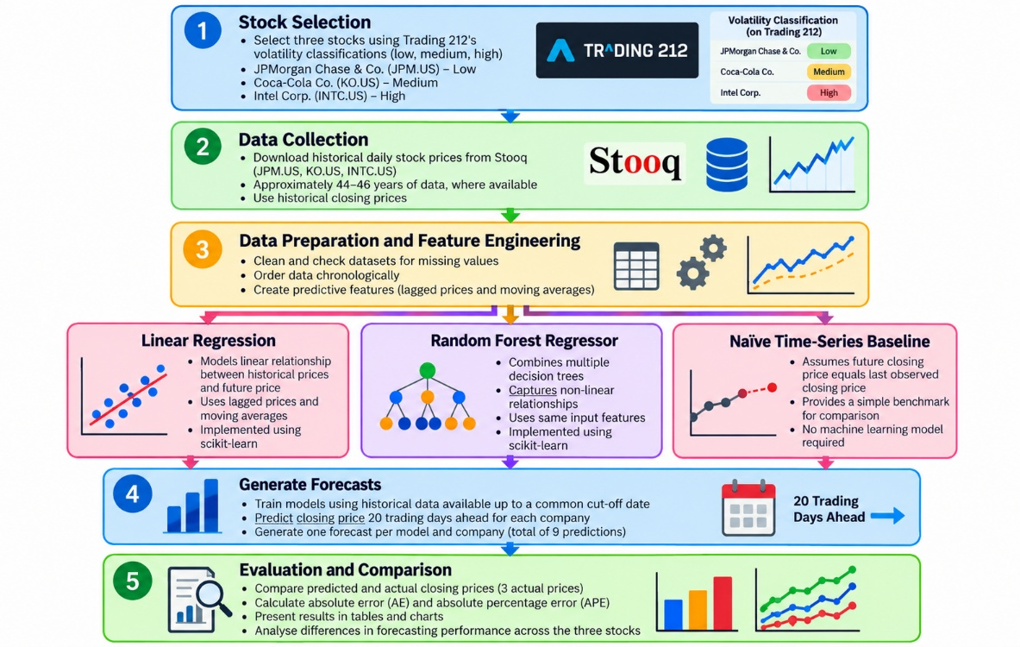
Figure 1: Capstone Project - High-level Architectural Chart

7. Data Sources
Trading 212 will be used to verify the volatility classifications of all the three selected stocks. JPM, KO, and INTC, respectively (Trading 212, n.d.). Screenshots supporting these classifications will be included in Appendix A.
Historical daily stock market data will be obtained from Stooq for all three companies (Stooq, 2026). The forecasting models will use historical closing prices to calculate lagged prices and moving averages.

8. Expected Deliverables
The expected deliverables for this Capstone Project will include a Jupyter Notebook containing data preparation, model training, nine predictions and forecasting error calculations. The results be presented through comparison tables and charts for the three selected stocks. A final report will discuss the findings, limitations and conclusions. A GitHub repository with contain the project code, documentation and datasets.

9. Project Timeline
This Capstone Project is planned across two academic semesters. The first semester will focus on the on defining the research question, reviewing relevant literature, verifying published Trading 212 volatility classifications, identifying data sources and proposed methodology.
The second will focus on data preparation, predictive model development, forecasting, evaluation, reporting and CA submission.
The proposed Gantt Chart (See Figure 2) illustrates the planned project activities and CA milestones.
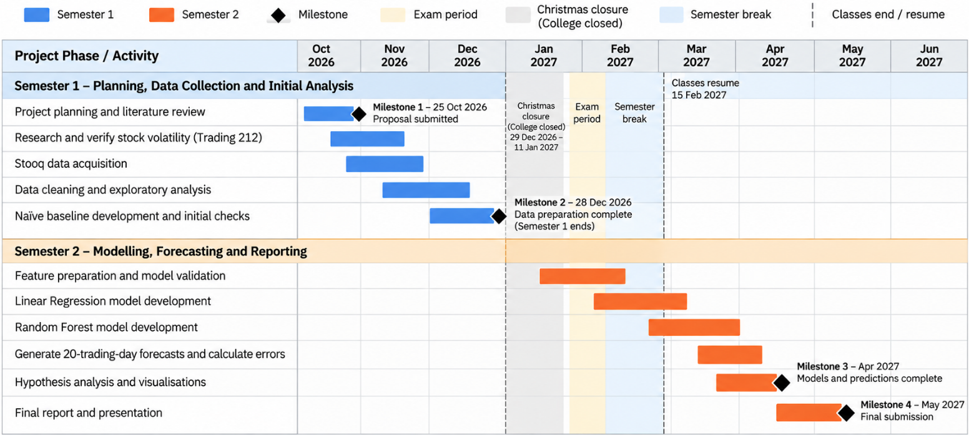
Figure 2: Capstone Project - Project Timeline

10. Ethical and Legal Considerations
This Capstone Project will use publicly available historical stock data and will not collect personal information or involve human participants. The data usage conditions of Stooq and Trading 212 will be reviewed, and both sources will be appropriately referenced.
All results, including inaccurate predictions, will be reported transparently. This Capstone Project work is for academic purposes only and does not constitute financial investment advice.

References
Divyashree, S., Joshua, C.J., MD, A. Q., Mohan, S., Abdullah, A.S., Mohamad, U.H., Innab, N. and Ahmadian, A. (2024) ‘Enabling business sustainability for stock market data using machine learning and deep learning approaches’, Annals of Operations Research, 342, pp.1-37. doi: https://doi.org/10.1007/s10479-024-06118-x (Accessed 12 October 2026).
Indra, Suipan, S., Sukono, Riaman, Saputra, M.P.A., Azahra, A.S. and Pirdaus, D.I. (2025) ‘Stock Return Predictions on the LQ45 Market Index in the Indonesia Stock Exchange Using a Machine Learning Algorithm Based on Technical Indicators’, Journal of Risk and Financial Management, 18(12), 714. doi: https://doi.org/10.3390/jrfm18120714 (Accessed 12 October 2026).
Jeribi, F., Martin, R.J., Mittal, R., Jari, H., Alhazmi, A.H., Malik, V., Swapna, S.L., Goyal, S.B., Kumar, M. and Singh, S.V (2024) ‘a Deep Learning Based Expert Framework for Portfolio Prediction and Forecasting’, IEEE Access, 12, pp. 1-20. doi: https://doi.org/10.1109/ACCESS.2024.3434528 (Accessed 12 October 2026).
Khuwaja, P., Khowaja, S.A., Khoso, I. and Lashari, I.A. (2020) ‘Prediction of stock movement using phase space reconstruction and extreme learning machines’, Journal of Experimental & Theoretical Artificial Intelligence, 32(1), pp.1-22. doi: https://10.1080/09052813X.2019.1620870 (Accessed 12 October 2026).
Stooq (2026) Historical data: Coca-Cola Co (KO.US). Available at: https://stooq.com/q/d/?s=ko.us (Accessed: 21 October 2026).
Stooq (2026) Historical data: Intel Corp (INTC.US). Available at: https://stooq.com/q/d/?s=intc.us (Accessed: 21 October 2026).
Stooq (2026) Historical data: JPMorgan Chase & Co (JPM.US). Available at: https://stooq.com/q/d/?s=jpm.us (Accessed: 21 October 2026).
Trading 212 (2026). Available at: https://www.trading212.com/ (Accessed: 21 October 2026).
Zain-ul-Abideen, Ali, R.H., Ijaz, A.Z. and Khan, T.A. (2024) ‘A Novel NLP-based Stock Market Price Prediction and Risk Analysis Framework’, Journal of Computer Science & Technology, 24(2), pp.1-15. doi: http://10.24215/16666038.24.e07 (Accessed 12 October 2024).

APPENDIX A

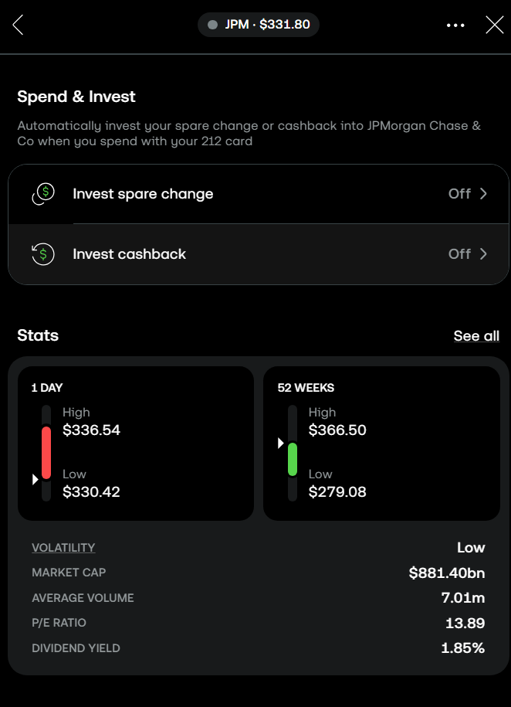
Figure 3: JPMorgan Chase & Co. (JPM) - Low Volatility Classification (Source: Trading 212, n.d).

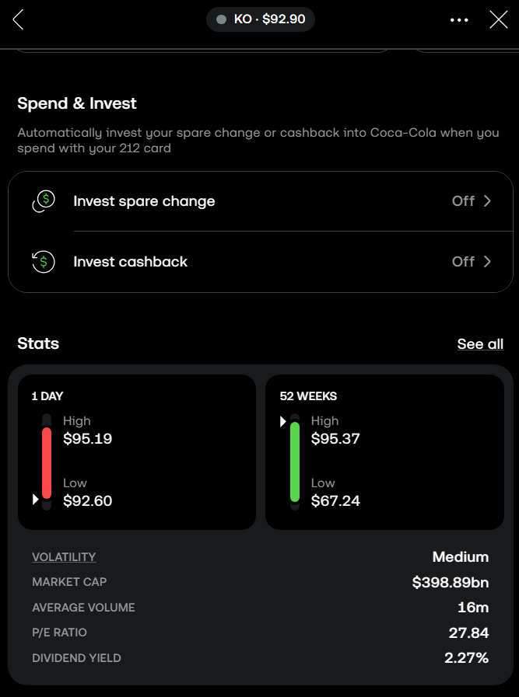
Figure 4: Coca-Cola Co. (KO) - Medium Volatility Classification (Source: Trading 212, n.d).

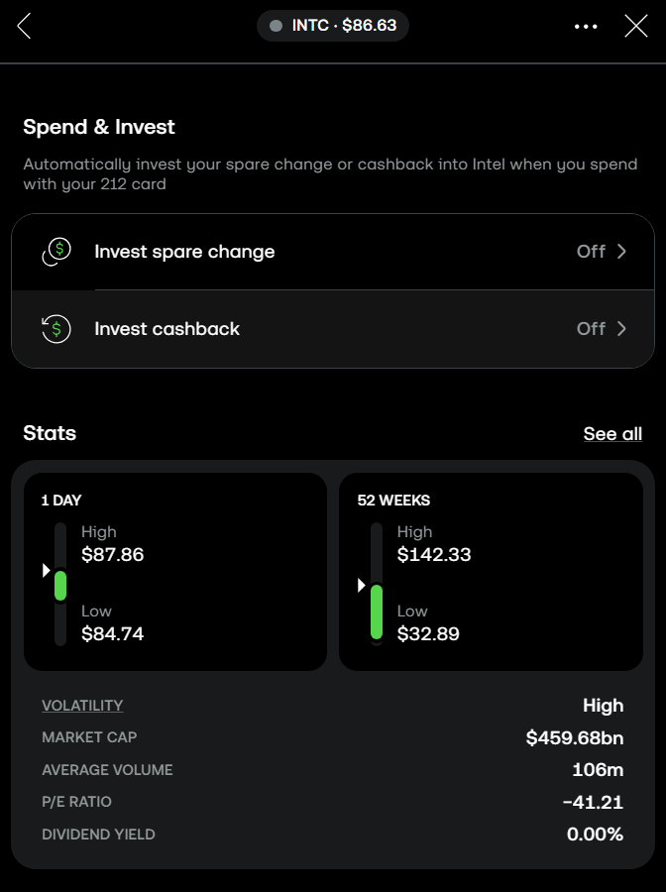
Figure 5: Intel Corp. (INTC) - High Volatility Classification (Source: Trading 212, n.d).

